

Hands-On Lab

Windows Azure: Worker Role Communication

Lab version: 1.0.0

Last updated: 12/15/2009

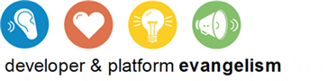

# System Requirements

* 1. You must have the following items to complete this lab:
  + IIS 7 (with ASP.NET, WCF HTTP Activation)
  + [Microsoft .NET Framework 3.5 SP1](http://www.microsoft.com/downloads/details.aspx?FamilyId=AB99342F-5D1A-413D-8319-81DA479AB0D7)
  + [Microsoft Visual Studio 2008 SP1 (or above)](http://msdn.microsoft.com/vstudio/products/)
  + [Windows Azure Tools for Microsoft Visual Studio (November 2009)](http://go.microsoft.com/fwlink/?LinkID=128752)

# Installation

* 1. You must perform the following steps to prepare your computer for **Windows Azure Worker Role Communication** lab.
  2. **Note:**  To perform the setup steps you need administrator privileges.
  3. For convenience, much of the code you will be managing along this hands-on lab is available as Visual Studio code snippets. The setup needed for this lab consist on checking the prerequisites of this lab and installing the code snippets. To do this:
  4. Run the **SetupLab.cmd** file located under the lab's **Source\Setup** folder.
  5. Follow the instructions to check the dependencies and install any that is missing.
  6. Once all the prerequisites are correctly installed, follow the wizard instructions to install the code snippets.
  7. The following are the steps to set up the Visual Studio snippets.
  8. When prompted, choose all items in the installer.
     1. 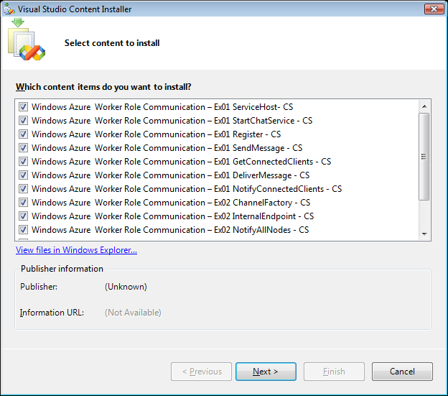
     2. Figure
     3. Code snippets for exercise
  9. A dialog window appears warning that the file is not signed; choose **Yes** to proceed anyway.
     1. 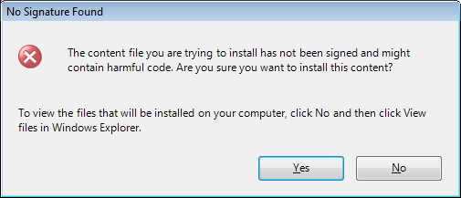
     2. Figure
     3. Warning dialog window
  10. When prompted for the location of the snippets, highlight all snippets, click the check box next to **My Code Snippets**, and click **Next**.
      1. 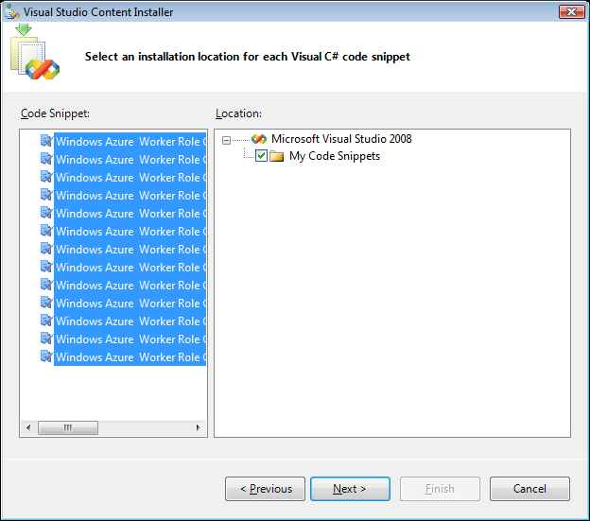
      2. Figure
      3. Installation location for lab snippets
  11. Click **Next** to continue.
      1. 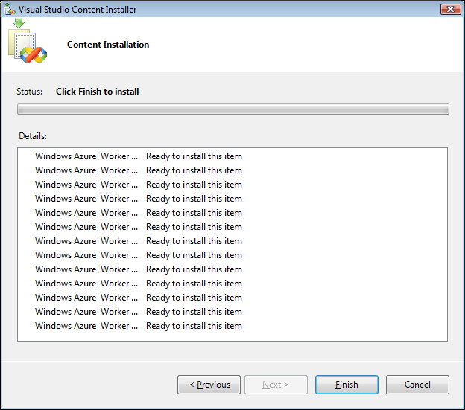
      2. Figure
      3. Installation confirmation for lab snippets
  12. Click **Finish.**
  13. The installation should proceed and install all snippets.
      1. 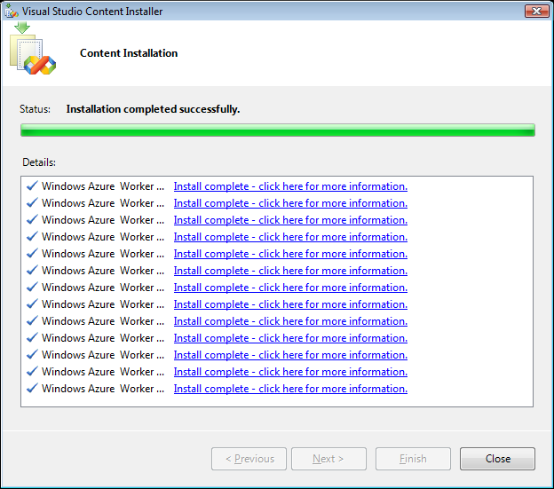
      2. Figure
      3. Installation confirmation